1.Project overview:

This application is made for a online computer parts shop. Our online inventory includes everything you need from full scale hologram Capable GPUs to state of the art engineered CPUs. We are able to design Server Hardware architecture and outstanding SonicWalls/FireWalls. The online site includes profile features and the ability for a customer to save their rating of an item. Customers accumulate a list of items for rating or Save to my parts.

Technical overview:

User Registration : Customers should be able to register with a site by creating an account that includes their information. User/admin Login, A user / admin should be able to retrieve a forgotten password A user that is registered with the site and has an account should have access to the following features: save an item, save item feedback

c.View / edit profile(this is the information captured when registering with the site)

d.View / edit items in profile

4.An application admin should have access to the following features:

a.Update catalog:

i.Add new items to catalog

ii.Edit item information

iii.Delete item

b.View/ edit users

Site Map:

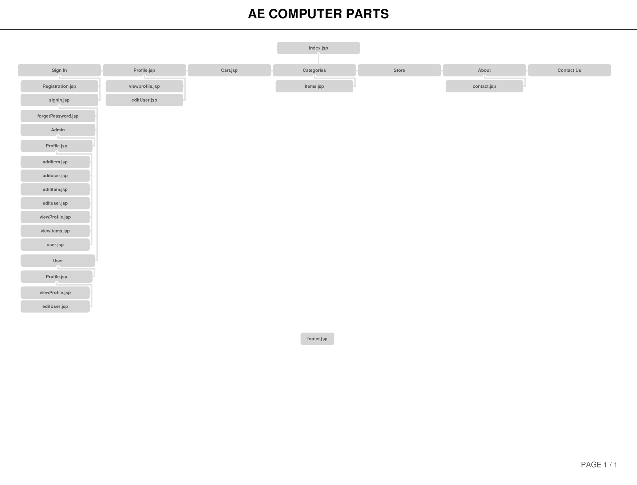

3. Page Design:

* The name of the page
* Purpose of the page
* Audience of page (customer, admin, etc.)
* What data (fields) will be presented on the page based on what logic?
* What validations (if any) will exist on page? (of data fields above)
* What buttons or hyperlinks will exist,and what actions will be taken when clicked (data saved, navigate to other page, search based on value, etc.)

|  |  |
| --- | --- |
| * About.jsp * Brief introduction about the website and the company | * Audience: Customers * Data: No data fields * Validation: Does not need validation * Buttons/hyperlinks: “Contact Us” hyperlinks to contact.jsp |
| * addItem.jsp * Allows admin to add an item to the database | * Audience: Admin * Data: 6 data fields (ItemCode, ItemName, CatalogCategory, Description, Rating, and ImageURL) * Validation: All items are validated before being added to the database * Buttons/hyperlinks: Submit button |
| * addUser.jsp * Allows the admin to add users to the database | * Audience: admin * Data: 10 data fields (UserID, FirstName, LastName, EmailAddress, Address1, Address2, City, State, PostCode, Country) * Validation: All items are validated before being added to the database * Buttons/hyperlinks: None |
| * Categories.jsp * This page list the categories and items. | * Audience: Customer * Data: No data fields * Validations: No validation * Hyperlinks: Clicking on the item will direct you to item.jsp |
| * Contact.jsp * Contains contact information for the customer or user | * Audience: Customers * Data: No data fields * Validation: Does not need validation * Buttons/hyperlinks: None |
| * editItem.jsp * Allows the admin to edit an item within the database | * Audience: Admin * Data: 5 data fields (ItemCode, ItemName, Description, Rating, ImageURL) * Validation: All the data fields are validated before they are added to the item * Buttons/hyperlinks: Submit button |
| * editUser.jsp * Provide customer profile information and allows them to edit the information | * Audience: Customer * Data: 10 data fields (UserID, FirstName, LastName, EmailAddress, Address1, Address2, City, State, PostCode, Country) * Validation: All data fields are validated when they are pulled from the database * Buttons/hyperlinks: submit button |
| * Feedback.jsp * This page allows the customer to edit the ratings of the computer parts | * Audience: Customer * Data: 1 data field (rating) * Validation: The rating is validated before it is pulled from the database * Buttons/hyperlinks: submit button |
| * Footer.jsp * This page is for the footer | * Audience: Customer and admin * Data: No datafield * Validation: No validation * Buttons/hyperlinks: none |
| * forgotPassword.jsp * This page is for users who forget their password and they are able to reset it | * Audience: Customers * Data: 9 data fields ( FirstName, LastName, EmailAddress, Address1, Address2, City, State, PostCode, Country) * Validation: All the data are validated before being pulled from the database * Buttons/hyperlinks: Submit button |
| * Header.jsp * This page is for the header | * Audience: Customer and admin * Data: No datafield * Validation: This page display the username at the top right and is being validated when pulled from the database. * Buttons/hyperlinks: none |
| * Index.jsp (Home) * Homepage for the website and provide information about the purpose of the website | * Audience: Customers and Admin * Data: No data * Validation: Does not need validation * Buttons/hyperlinks: None |
| * items.jsp * This page is dynamically generated which displays information about the page you have selected | * Audience: Customers and admin * Data: No data fields * Validation: All the dynamic data are being validated when being pulled from the database * Buttons/hyperlinks: None |
| * Profile.jsp * Dynamically generated which saves all the computer parts you have saved | * Audience: Customer * Data: No data fields * Validation: validation when the items are being pulled from the database * Buttons/hyperlinks: There is a button for update and delete. The delete button removes the saved computer parts. The update button navigates to the feedback page which let’s them change the ratings. |
| * Registration.jsp * This page is a form which lets the customer create a user in the database | * Audience: Customers * Data: 10 data fields (UserID, FirstName, LastName, EmailAddress, Address1, Address2, City, State, PostCode, Country) * Validation: All data fields are validated when they are pulled from the database * Buttons/hyperlinks: Submit button |
| * Signin.jsp * This page appears when you attempt to log in | * Audience: Customers and Admin * Data: 2 data fields (email and password) * Validation: Both data fields are validated for correct input * Buttons/hyperlinks: Login button (submit) |
| * User.jsp * This page allows you to add user | * Audience: Admin * Data: No data fields * Validation: Does not need validation * Buttons/hyperlinks: Add User button links to addUser.jsp |
| * viewItems.jsp * This page list all of the items in the database which allows access to editing the items | * Audience: Admin * Data: No datafield * Validation: Each item are validated before shown on the page * Buttons/hyperlinks: None |
| * Viewprofile.jsp * This page displays all of the user’s information | * Audience: Customers and admin * Data: No data fields * Validation: Dynamic data which is validated before being pulled from the database * Buttons/hyperlinks: hyperlink to editUser.jsp |

ER Diagram of MySQL database designed.

